GROUP ACTIVITY OF PYTHON
Names: IGIRANEZA Bora Uzima
MVUTSENEZA Anastese
BYIRINGIRO Marcel
SIMBIZI Yvan

PREPARETION AND INSTALLETION OF PYTHON
The following step is how can install python:
- Download the Python installation file from Python.org.
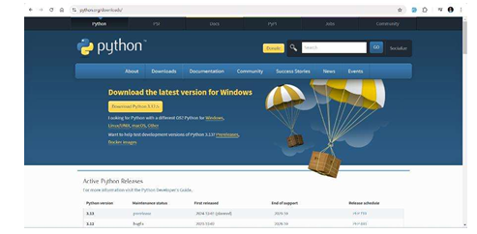
- Run the installer and accept the license agreement.
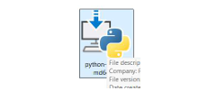
- Choose to add python.exe to your operating system's PATH.
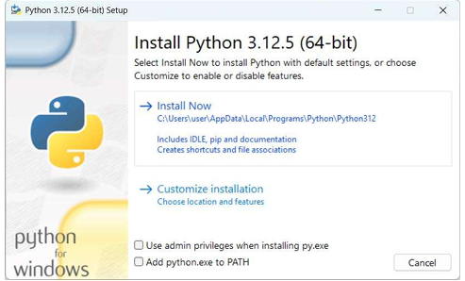
- Accept all of the default options.
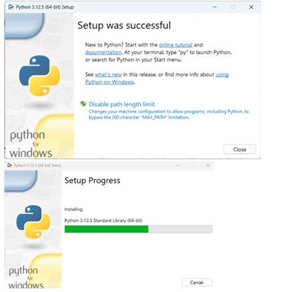
- Click Finish when the installation completes.

Some example of python code:
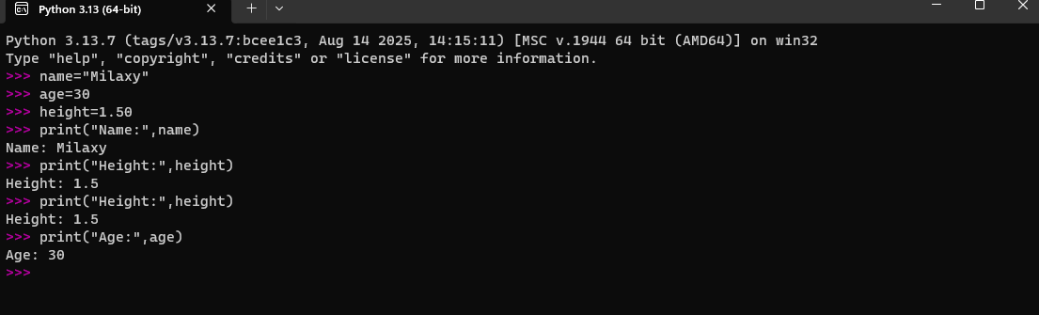

END.

